LGCWEEK xXx - ??????? Shouldn’t it be 360?
Colour key - Venn Jordan Pedro
The Jordan
https://meet.jit.si/jordan9000#config.disableAP=true&config.disableAEC=true&config.disableAGC=true

The Pedro
https://meet.jit.si/pedro9000#config.disableAP=true&config.disableAEC=true&config.disableAGC=true

Need to remember - post finished show in google Linux group.

PICK YOUR FUKIN’ STORIES!

Remember to ask shatrealm to come up with Show Title.

Intro-
grep ^http links.txt | tr "\n" " " | sed 's/\&/\\\&/g' | xargs firefox lynx curl

Vote for Showtitles: vote.linuxgamecast.com

INTRO : ???????????????????????????? <- !!!!!!!!!!!!!!!!

Rundown:

Steam's new shader compiler goes turbo
But only for AMD
And Ion Maden changes names
And gets a price bump.

Ride the death machine! Clear all the fields!
- Just don’t forget to re-enable your mods
RPCS3 Has new update
- Soon there will be more working games than not. Spoon...

Steam gives us some sliders
- Not the 90s TV show, unfortunately
And RetroArch is coming to Steam
- But not for Linux… at first.

What we’re up to :
V - Playing with TUBES!
J - turns out I can deadlift 500lbs a bunch of times without pooping my pants #winning
P -

Colour key: Venn Jordan Pedro
Party Patreons: Post story suggestions HAR!

Links
Steam: News

Interactive recommender
https://steamcommunity.com/games/593110/announcements/detail/1612767708821405787
- No OS filter…
- Having solved all other Steam issues.
- Seems like a more advanced version of their discoverability queue?
  - With even less interaction
- You get two sliders and a hidden algorithm that interprets those two sliders along with the playtime of games in your library.

Steam Labs
https://store.steampowered.com/labs
- So we got the aforementioned sliders, and two trailer experiments. One that tries to get about 5 seconds of gameplay and another that stitches trailers together and produces a script based on the steam description for a human to read
- The latter two kind of remind me of stuff that was on G4 or Electric Playground, but we have youtube now
- Can we just get the library update?

Steam Link version 1.1.36
https://steamcommunity.com/app/353380/discussions/6/1642041886371250832/
- Cuz Valve can’t be fucked to make their own steam link hardware, you can
- Added the device form factor for an upcoming Steamworks API
  - Interesting. Let’s spool up the speculation drive.
  - Pi Steam confirmed.
  - Or maybe an API for using it to make custom peripherals?
- Pi4 is wee overkill for a Steam Link, I approve!

Retro Steam (eMpTy)
https://www.libretro.com/index.php/retroarch-coming-to-steam-this-month-july-30/
- Windows only at first… -.-
- This gets interesting if we could get some type of multiplayer shim for games.
- The world needs LGC plays Battle Toads.
- Cloud syncs for emulator saves would be nice.

ACO NeiR
www.forbes.com/sites/jasonevangelho/2019/07/11/valves-latest-linux-gaming-work-is-boosting-amd-vulkan-performance-by-up-to-44-percent/
- Valve pointed out that most games tested appear mostly unaffected in terms of runtime performance.
- However a few showed notable improvement.
- With NeiR ACO delivered a 44% boost, landing it 12% higher than native Windows performance.
- This is not terribly surprising since the Windows version runs like junk without the community created FAR MOD.
- That’s the comparison I’m interested in.
- Like I said last week. Very interesting stuff coming down the pipe with this project
- We’ve had a few instances where wine will outperform native and while this isn’t going to be the norm, it is nice to be able to thumb our noses at windows performance every once in a while
Steam: Game Updates

Iron not Maiden
https://steamcommunity.com/games/562860/announcements/detail/1619524466602443850
- They couldn’t afford a prolonged lawsuit.
- Price increase to $24.99 starting Jul 18.
- First Blood now Ion Maiden Fury.
- 2019 is the year of the Duke 3D engine.
- Well, now they’re infringing on my all mascot glam rock band Iron Furry. So now I gotta sue

Besiege 0.85
https://steamcommunity.com/games/346010/announcements/detail/1609390009096220682
- Legos for Sociopaths gets 2 new levels
- You can also now fully rebind the base controls
- They added tagging and searching to your library of horrifying death machines
- You’ll need to manually re-enable mods after this update
- It still launches… in a void unconnected to any of my fkn displays.
- This has been an issue for the last couple of versions.

Tannenberg controller support
https://steamcommunity.com/games/tannenberg/announcements/detail/1611641808912913739
- Why you’d want to play a gritty iron sights FPS with a controller is beyond me, but you can.
- They’ve updated multiplayer so that new players tend to get assigned to the non winning team to reduce the steamroller effect
  - I’d rather them make actually getting into a multiplayer game easier, but whatevs
- Fixed haystack collision!
- I have no idea why that was a thing that needed fixing, but it sounds hilarious.
Steam: New Games

Eagle Island
https://store.steampowered.com/app/681110/Eagle_Island/
- Murderbirds: The game
- It’s no Owlboy but there is a boy and an owl!

Clea / 克莉
https://store.steampowered.com/app/981020/Clea/
- Animoo survival horror.
- Something tells me both Ass and Mir would really enjoy this
- Darkest Anime Dungeon?

Godhood
https://store.steampowered.com/app/917150/Godhood/
- Needs more giant monkeys flinging flaming feces
- Reviews are mixed and, reading some of them, it looks like this isn’t so much a god sim as a nanny sim.
- The folks don’t do jack unless you specifically tell them too.

Plugs
Patreon:
- Discord
- Early note access
- Name in credits
- Access to UNCUT VOD’s 3 days early.
- RSVP for game streams.
- Buy your way onto the damn show.

News:

DXVK 1.3
https://github.com/doitsujin/dxvk/releases/tag/v1.3
- Discard optimization.
- Asynchronous presentation.
- Removed busy-waiting during presentation.

D9VK 0.13
https://github.com/Joshua-Ashton/d9vk/releases/tag/0.13
- Bayonetta still nopes with xinput.
- WINEPREFIX=/media/STEAMY/SteamGames/steamapps/compatdata/460790/pfx/ WINEARCH=win64 ./setup_dxvk.sh install
- ^ Decypher this for install.
- The one game I want to use it for nopes if you touch the controller.

RPCS3 May update
https://rpcs3.net/blog/2019/07/09/progress-report-may-2019/
- They are a little behind but trying to play catchup.
- Surface Caching and SPU improvements make a bunch of games playable
- Same number of game playable as the ones which only technically get in game.

Death Rally
https://github.com/urxp/drally
- Right now it only builds a DOS exe, but you can do all sorts of magical crap if you have the source code
- I played the demo/shareware!

LGPL virtual console
https://github.com/morgan3d/quadplay
- I guess this is supposed to be like a chip or pi VM
- I suppose it’s well within the realm of possibility that someone will take a PiZero and actually make a physical version of the console

CHAIRQUISITION:
- Nooope
- Not sure if want
- Check it out
- Shutupandtakemymonies

Welcome to the Chairqasition!
Where the accused must survive trial by Fedora, Solus, and Fedorf.
Then and only then can the question be asked, is it fun?

Game: Toy story from Hell
Devel: Supra Games
Engine: Unreal Engine 4
Price: £15.49 / US$19.99 / CA$22.79
Wazzat: Supraland is a First-Person Metroidvania Puzzle game. The main sources of inspiration are Zelda, Metroid and Portal.

Mandatory Disclosure: Devs sent us keys via Curator Connect

Pass|Fail 


Venn:
Does It Launch
- Fullscreen just your maxes resolution.
- Want 1080? Hope you like windowed.
Performance @ 1080
- It’s poo Brad, poo.
- Granted it’s smooth poo but something is not right.
- 50 @1080 and 30 @ 2160.
- But hey, it’s good knowing my 2060 runs the same as a 1080… and a 1080Ti.
Graphics
- Better than your average indie.
- No glitches.
Control
- Controller does not work in menu.

Jordan:
Does It Launch
- Yorp
Performance @ 1080
- When in a tiny window, it can hold 55-60 easily at 1080P
- Fullscreen eats a bag
Graphics
- It looks like stock unreal asset toy story
Control
- Wasd


Pedro:
Does It Launch
- It do
Performance @ 1080
- 30 FerPS, that’s all it could do in fullscreen.
- 1080p windowed holds between 50 and 60 with everything on 11.
Graphics
- It’s certainly got that UE4 lens flare.
- Even the tiniest of light sources has this massive bloom around it.
Control
- Movement takes some getting used to as does the 3D jumping but hey! You can see your feet.

QA Score:
Fedora:
Soulless:
Fedorf:

Fun section:
Fun?:
- Venn:
  - I’ve taken exactly two screenshots of this game.
  - 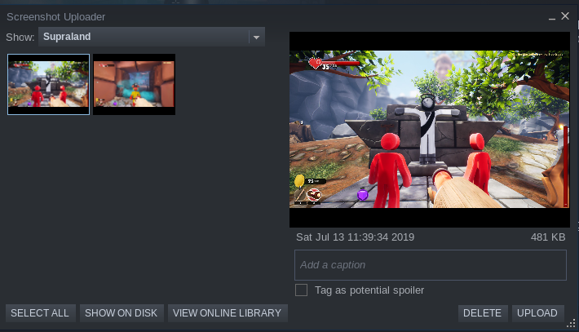
  - This is an incredibly well done puzzle sandbox.
  - We’re talking Portal level quality puzzles.
  - Ya know, the kind that piss you off and keep you coming back for more.
  - There is zero hand holding outside of characters giving the occasional hint.
  - The first hour was spent trying to figure out what the hell to do.
  - After you put 2 and 13 together it’s off to the races.
  - Plenty of places to explore and secrets to find.
  - And there is just enough not trying too hard humour to keep the mood light and interesting.
  - My only complaint is the combat.
  - That shit is weak and we both know it.
  - At least you can unlock the ability to make baddies drop coin so their mild annoyance pays off.
  - Because that’s all the baddies are, mild annoyances.
  - One thing Portal got right... but somebody just had to justify putting a Zelda sword in their game.
  - Eh, between that and the something is obviously wrong performance I can give it three.
  - Even at $20 it should keep you busy for a while.
- Jordan
  - 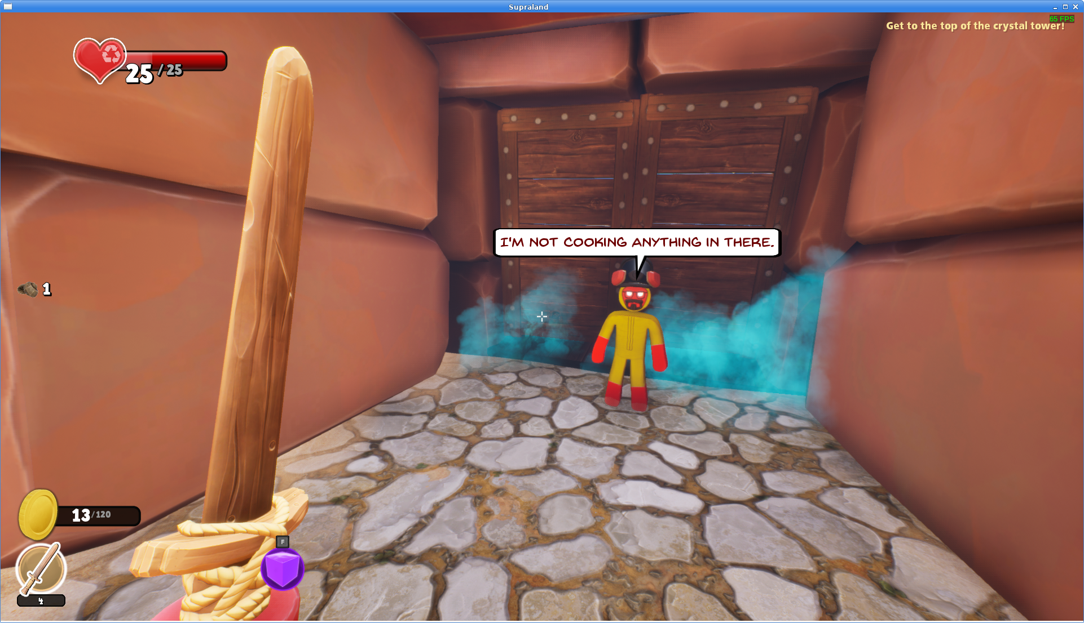
  - 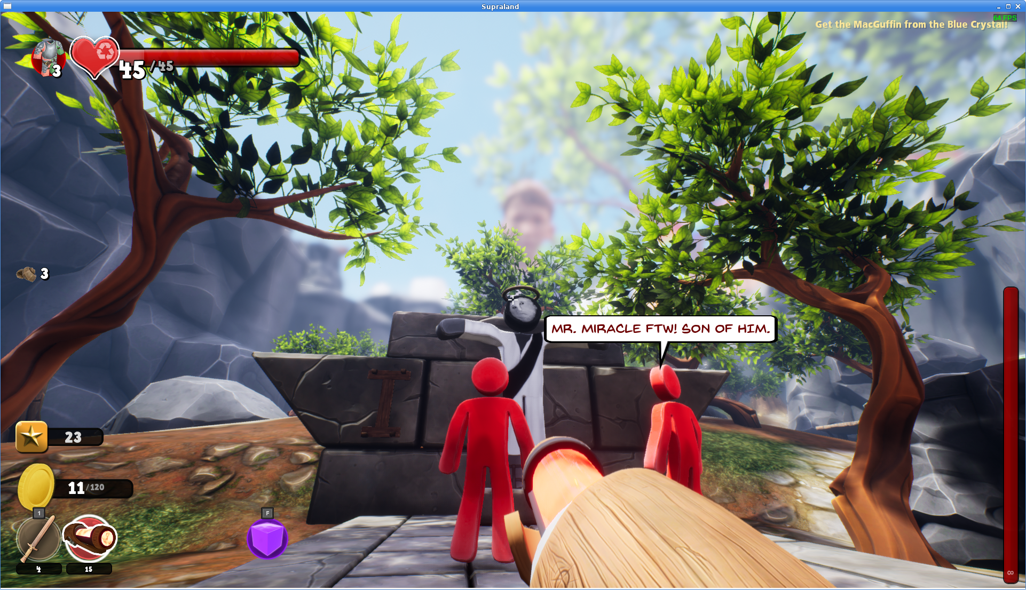
  - Almost like this game directly addresses one of the complaints I have from last week, this is basically fuck around in the environment, the game
  - And its got a lot going for it. Big map, lots of puzzles, upgrades, secrets. It’s genuinely fun to explore the place. Plus the devs have a decent sense of humour
  - There’s even a little nod to the breath of the wild starting area. And by little nod I mean they basically ripped it off. But it’s a good way to get people thinking about how to engage with the mechanics in your sandbox
  - The one thing I gotta ding it for is that the platforming is pretty crappy. First person platforming is never gonna be great, and this game doesn’t do it any better than anyone else
  - Everything else is pretty solid though. MInus teh whole performance at fullscreen thing. That’s not great
- Pedro
  - When devs go out of their way to name all their inspirations, I have this urge to pick at the nits.
  - However, when your map is laid out like Zelda, with metroidvania-like mechanics and a puzzle system which, much like Portal, requires a bit of lateral thinking, I’m left a bit disarmed.
  - Heck even the gun mcguffin looks a little like Samus’ arm cannon.
  - Supraland is a first person metroidvania which isn’t afraid to wear its inspirations on its sleeve.
  - And I like it a lot because of that!
  - It’s one of those games where I lose track of time.

Fun Score:
Venn:
Jordan:
Pedro:

Hate Mail:

Link-s
https://linuxgamecast.com/bradley/?zMVL16J
- These can be added, we have the technology.
- Granted, this is the first request for it in the history of ever.

Streets of halp
https://linuxgamecast.com/bradley/?kpwxrV2

After:

